Emulation : In [computing](https://en.wikipedia.org/wiki/Computing), an **emulator** is [hardware](https://en.wikipedia.org/wiki/Computer_hardware) or [software](https://en.wikipedia.org/wiki/Software) that enables one [computer system](https://en.wikipedia.org/wiki/Computer_system) (called the *host*)

CLI: Command Line Interface

NVRAM: non-volatile random-access memory, NVRAM (non-volatile random-access memory) refers to computer memory that can hold data even when power to the memory chips has been turned off. NVRAM is a subset of the larger category of non-volatile memory ([NVM](https://www.techtarget.com/searchstorage/definition/nonvolatile-memory)), which includes storage-class memory based on NAND flash.

SVI: switch virtual interface

IOS: Internetwork operating system

Exhibit: publicly display (a work of art or item of interest)

DHCP: Dynamic Host Configuration Protocol

DSL: digital subscriber line

Proprietary: relating to an owner or ownership.

The [Session. Contents](https://docs.microsoft.com/en-us/previous-versions/iis/6.0-sdk/ms525093(v=vs.90)) collection contains all of the items that have been established for a session without using the <OBJECT> tag.

**medium access control** (**MAC**, also called **media access control**)

### Which PDU format is used when bits are received from the network medium by the NIC of a host?

* file
* frame
* packet
* segment

**Explanation:**

When received at the physical layer of a host, the bits are formatted into a frame at the data link layer. A packet is the PDU at the network layer. A segment is the PDU at the transport layer. A file is a data structure that may be used at the application layer.

### Which PDU is processed when a host computer is de-encapsulating a message at the transport layer of the TCP/IP model?

* bits
* frame
* packet
* segment

**Explanation:**

At the transport layer, a host computer will de-encapsulate a segment to reassemble data to an acceptable format by the application layer protocol of the TCP/IP model.

### At which layer of the OSI model would a logical address be encapsulated?

Logical addresses, also known as IP addresses, are added at the network layer. Physical addresses are edded at the data link layer. Port addresses are added at the transport layer. No addresses are added at the physical layer.

### Refer to the exhibit. If Host1 were to transfer a file to the server, what layers of the TCP/IP model would be used?

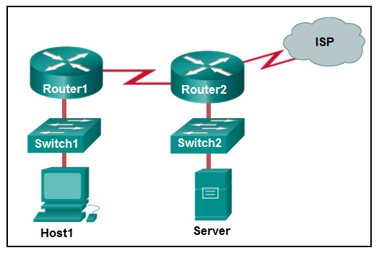

* only application and Internet layers
* only Internet and network access layers
* only application, Internet, and network access layers
* application, transport, Internet, and network access layers
* only application, transport, network, data link, and physical layers
* application, session, transport, network, data link, and physical layers

|  |
| --- |
|  |

The TCP/IP model contains the application, transport, internet, and network access layers. A file transfer uses the FTP application layer protocol. The data would move from the application layer through all of the layers of the model and across the network to the file server.

### Refer to the exhibit. HostA is attempting to contact ServerB. Which two statements correctly describe the addressing that HostA will generate in the process? (Choose two.)

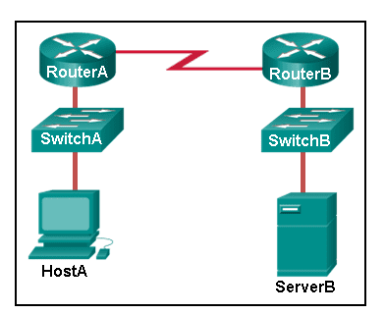

* A packet with the destination IP address of RouterB.
* A frame with the destination MAC address of SwitchA.
* A packet with the destination IP address of RouterA.
* A frame with the destination MAC address of RouterA.
* A packet with the destination IP address of ServerB.

**Explanation:**

In order to send data to ServerB, HostA will generate a packet that contains the IP address of the destination device on the remote network and a frame that contains the MAC address of the default gateway device on the local network.

### Which address does a NIC use when deciding whether to accept a frame?

* source IP address
* source MAC address
* destination IP address
* destination MAC address
* source Ethernet address

### What will happen if the default gateway address is incorrectly configured on a host?

* The host cannot communicate with other hosts in the local network.
* The switch will not forward packets initiated by the host.
* The host will have to use ARP to determine the correct address of the default gateway.
* The host cannot communicate with hosts in other networks.
* A ping from the host to 127.0.0.1 would not be successful

**Explanation:**

When a host needs to send a message to another host located on the same network, it can forward the message directly. However, when a host needs to send a message to a remote network, it must use the router, also known as the default gateway. This is because the data link frame address of the remote destination host cannot be used directly. Instead, the IP packet has to be sent to the router (default gateway) and the router will forward the packet toward its destination. Therefore, if the default gateway is incorrectly configured, the host can communicate with other hosts on the same network, but not with hosts on remote networks.

### Which characteristic describes the default gateway of a host computer?

* the logical address of the router interface on the same network as the host computer
* the physical address of the switch interface connected to the host computer
* the physical address of the router interface on the same network as the host computer
* the logical address assigned to the switch interface connected to the router

The default gateway is the IP address of an interface on the router on the same network as the sending host.

### Match the protocol function to the description while taking into consideration that a network client is visiting a web site. (Not all options are used.)

When a web client visits a web server, several network communication protocols are involved. These different protocols work together to ensure that the messages are received and understood by both parties. These protocols include the following:

* **Application Protocol** – governing the way a web server and a web client interact
* **Transport Protocol** – managing the individual conversations between web servers and web clients
* **Internet Protocol** – taking the formatted segments from the transport protocol, encapsulating them into packets, assigning them the appropriate addresses, and delivering them across the best path to the destination host
* **Network Access Protocol** – preparing packets to be transmitted over the network media

**Network Time Protocol** is used to synchronize clocks between computer systems. It is not involved in this case.

### Which name is assigned to the transport layer PDU?

* bits
* data
* frame
* packet
* segment

Application data is passed down the protocol stack on its way to be transmitted across the network media. During the process, various protocols add information to it at each level. At each stage of the process, a PDU (protocol data unit) has a different name to reflect its new functions.

**The PDUs are named according to the protocols of the TCP/IP suite: Data – The general term for the PDU used at the application layer.**

**Segment – transport layer PDU  
Packet – network layer PDU  
Frame – data link layer PDU  
Bits – A physical layer PDU used when physically transmitting data over the medium**

**Protocol data units for the**[**Internet protocol suite**](https://en.wikipedia.org/wiki/Internet_protocol_suite)**are:**

**The**[**transport layer**](https://en.wikipedia.org/wiki/Transport_layer)**PDU is the**[**TCP segment**](https://en.wikipedia.org/wiki/TCP_segment)**for TCP, and the datagram for UDP.**

**The**[**Internet layer**](https://en.wikipedia.org/wiki/Internet_layer)**PDU is the**[**packet**](https://en.wikipedia.org/wiki/Network_packet)**.**

**The**[**link layer**](https://en.wikipedia.org/wiki/Link_layer)**PDU is the**[**frame**](https://en.wikipedia.org/wiki/Frame_(networking))

### OSI model**[**[**edit**](https://en.wikipedia.org/w/index.php?title=Protocol_data_unit&action=edit&section=3)**]**

Protocol data units of the [OSI model](https://en.wikipedia.org/wiki/OSI_model) are:[[1]](https://en.wikipedia.org/wiki/Protocol_data_unit#cite_note-1)

* The Layer 4: [transport layer](https://en.wikipedia.org/wiki/Transport_layer) PDU is the [segment](https://en.wikipedia.org/wiki/Packet_segment) or the datagram.
* The Layer 3: [network layer](https://en.wikipedia.org/wiki/Network_layer) PDU is the [packet](https://en.wikipedia.org/wiki/Network_packet).
* The Layer 2: [data link layer](https://en.wikipedia.org/wiki/Data_link_layer) PDU is the [frame](https://en.wikipedia.org/wiki/Frame_(networking)).
* The Layer 1: [physical layer](https://en.wikipedia.org/wiki/Physical_layer) PDU is the [bit](https://en.wikipedia.org/wiki/Bit) or, more generally, [symbol](https://en.wikipedia.org/wiki/Symbol_(data)).

Given a context pertaining to a specific OSI layer, *PDU* is sometimes used as a synonym for its representation at that layer.

### Internet protocol suite**[**[**edit**](https://en.wikipedia.org/w/index.php?title=Protocol_data_unit&action=edit&section=4)**]**

Protocol data units for the [Internet protocol suite](https://en.wikipedia.org/wiki/Internet_protocol_suite) are:

* The [transport layer](https://en.wikipedia.org/wiki/Transport_layer) PDU is the [TCP segment](https://en.wikipedia.org/wiki/TCP_segment) for TCP, and the datagram for UDP.
* The [Internet layer](https://en.wikipedia.org/wiki/Internet_layer) PDU is the [packet](https://en.wikipedia.org/wiki/Network_packet).
* **The**[**link layer**](https://en.wikipedia.org/wiki/Link_layer)**PDU is the**[**frame**](https://en.wikipedia.org/wiki/Frame_(networking)).